TITLE OF ARTICLE (11 times new roman, bold, UPPER CASE)
Name of Author (-s) (11 times New Roman, Capital Letters)
Abstract. Brief summary of article in English 3-4 scale rows. Brief summary of article in English 3-4 scale rows. Brief summary of article in English 3-4 scale rows. Brief summary of article in English 3-4 scale rows. Brief summary of article in English 3-4 scale rows. (9 times new roman.)
Title of Chapter 1 (11 bold times...) spacing – up 18 down 6
First line 0,6 cm text text text text text text text text text text text text text text text text text text text text text text text text text text text text text text text text text text text text text text text text text text text text text text text text text text text text text text text text text text text text text text text text text text text text text text text v text text text text text text text text text text text text text text text text text text text text text text text text text text text text text text text text text text text text text text text text text text text text text text text text text text text text text text text ...(11 times .........)
Title of Chapter 2 (11 bold times...) spacing – up 18 down 6
First line 0,6 cm text text text text text text text text text text text text text text text text text text text text text text text text text text text text text text text text text text text text text text text text text text text text text text text text text text text text text text text text text ...
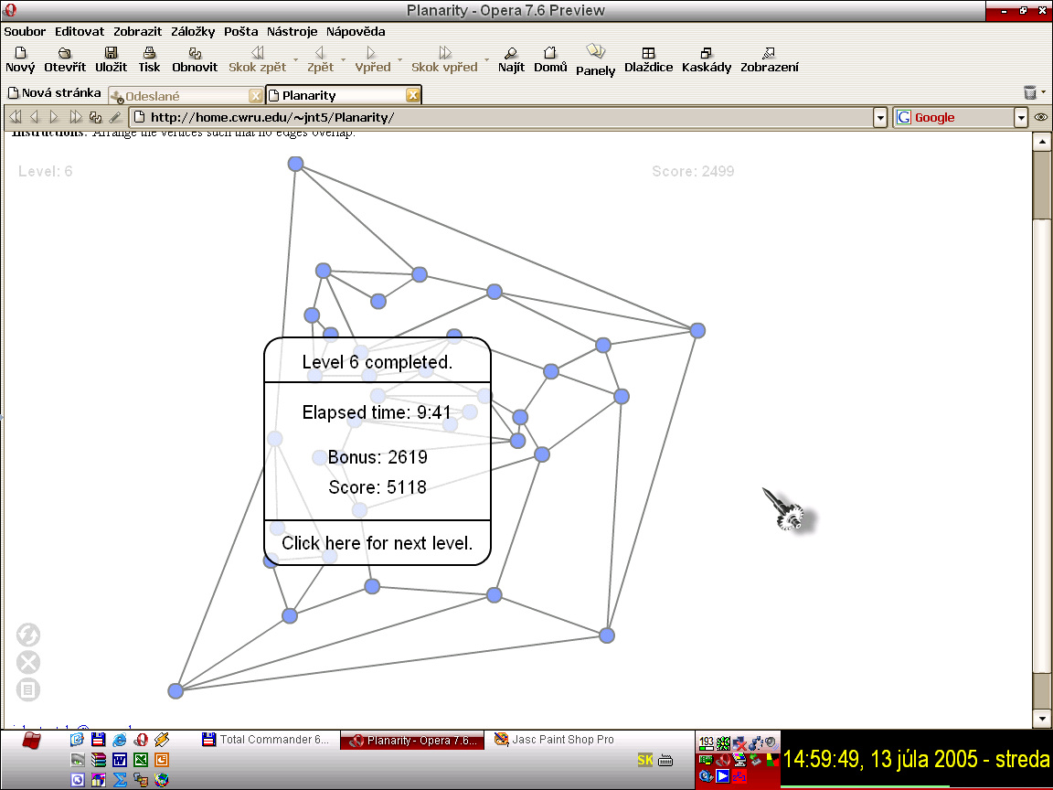
Figure 1: comments are obligatory (10 italic times ...) spacing up 6 down 18

Table 1: comments are obligatory (10 italic times ...) spacing up 6 down 18

................... text ...............

.
.
.
end of the text of contribution
References
[1] Author name: Publiciation name, characteristic, Town, Publisher, 1993, ISBN 80-80xx-xxx-x
[2] Author name: Publiciation name, characteristic, Town, Publisher, 1993, ISBN 80-80xx-xxx-x
…
prof. John Doe, PhD.
Department of Mathematics
Faculty of Natural Sciences
Constantine the Philosopher University in Nitra
Trieda A. Hlinku 1
SK – 949 01 Nitra
e-mail: name@anywhere.xx

Footnote 8 times new roman ...

