head title in english (style head Title)
Author – Autor (-s) – Authors (Style Authors)
• Please, submit your manuscript via an online submission system. In text, you can replace any information that would identify the author(s) by substituting words such as: [name deleted - review process] or [address deleted – review process].
• Details of the author(s) or any other informations submit an extra title page as an email attachment to editor via nitra.conference@gmail.com
• Informations will be added later - after reviews and an acceptance of manuscript.
Abstract. Brief summary of article, min 10, max 15 scale rows (style Abstract style). Brief summary of article, min 10, max 15 scale rows (style Abstract style). Brief summary of article, min 10, max 15 scale rows (style Abstract style). Brief summary of article, min 10, max 15 scale rows (style Abstract style). Brief summary of article, min 10, max 15 scale rows (style Abstract style). Brief summary of article, min 10, max 15 scale rows (style Abstract style). Brief summary of article, min 10, max 15 scale rows (style Abstract style). Brief summary of article, min 10, max 15 scale rows (style Abstract style). Brief summary of article, min 10, max 15 scale rows (style Abstract style). Brief summary of article, min 10, max 15 scale rows (style Abstract style). Brief summary of article, min 10, max 15 scale rows (style Abstract style). Brief summary of article, min 10, max 15 scale rows (style Abstract style).
Key Words: 3-4 key words (style Abstract)
Classification: see http://www.zentralblatt-math.org/matheduc/classification/

Heading 1, style Nadpis 1

The first page that reviewers should see should not contain author names or affiliations but should contain only the title, abstract and keywords, with no acknowledgements, footnotes or any other information identifying the authors.

Text text text text text text text text text text text text text text text text text text text text text text text text text text text text text text text text text text text text text text text text text text text text text text text text text text text text text text text text text text text text text text text text text text text text text text text text text text text text text text text text text text text text text text text text text text text text text text text text text text text text text text text text text text text text text text text text text text text text text text text text text text text text text text ...(style Text of article).

The maximum range of paper is limited to 6 pages. The longer papers can be accepted after editor agreement – the extra pages of paper can be charged 10 € per page (please don´t insert the numbers of the pages).

Heading 2 , style Nadpis 2
Text text text text text text text text text text text text text text text text text text text text text text text text text text text text text text text text text text text text text text text text text text text text text text text text text text text text text text text text text text text text text text text text text text text text text text text text text text text text text text text text text text text text text text text text text text text text text text text text text text text text text text text text text text text text text text text text text text text text text text text text text text text text text text.

Heading 1, style Nadpis 1
Text text text text text text text text text text text text text text text text text text text text text text text text text text text text text text text text text text text text text text text text text text text text text text text text text text text text text text text text text ...
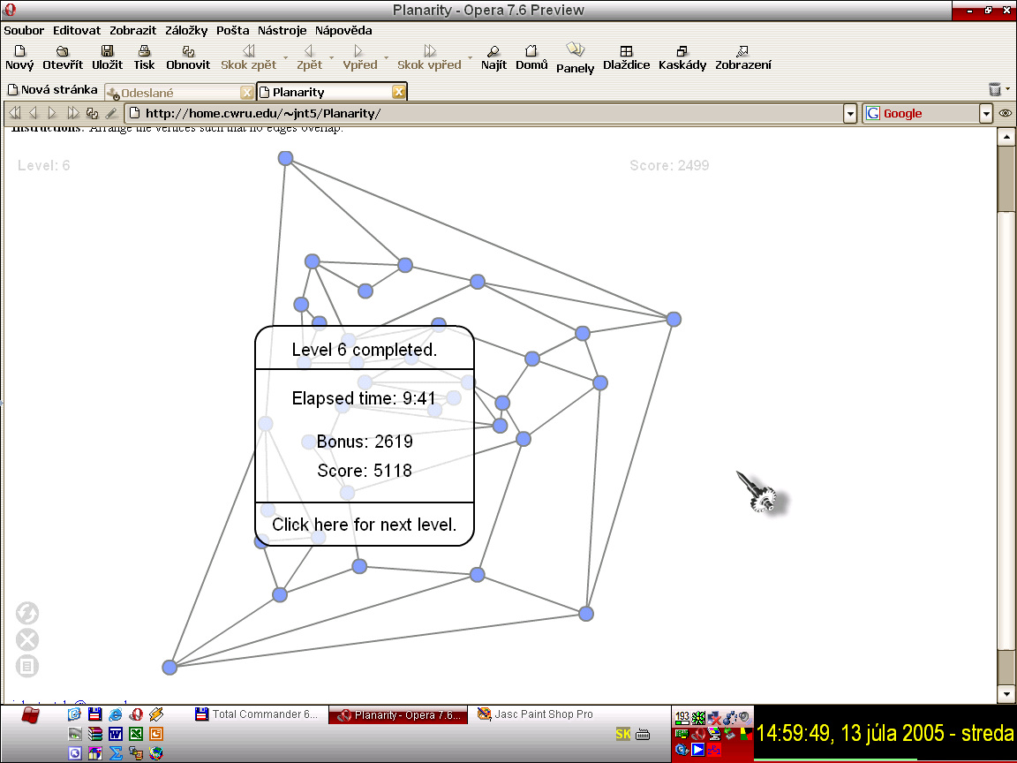
Figure 1: Comment is not necessary (style Figure table comment)
Name of tables detto: style Figure table comment

................... text ...............

Conclusion/Discussion (Style Nadpis 1)
Text text text text text text text text text text text
The maximum range of paper is limited to 6 pages. The longer papers can be accepted after editor agreement – the extra pages of paper can becharged 10 € per page (please don´t insert the numbers of the pages).

References (style Nadpis 1)
- Smith, J., Schwartz, M. 2013. Introduction to mathematics. Bratislava: Springer, 2013. 250 p. ISBN 80-80xx-xxx-x (Book example)
- Smith, J., Schwartz, M. 2013. Introduction to mathematics. In: Journal of mathematics education, Vol. 25 (11), 2013. P. 158-167. ISSN 8080-xxxx (journal article example)
- Smith, J., Schwartz, M. 2013. Introduction to mathematics. In: Williams, J., Perry, M. (Eds) Mathematics everywhere - conference proceedings. Berlin: Springer, 2013. P 158-167. ISBN 80-80-xx-xxx-x (conference proceeding example)
- Name of authors or organisation. Year (if is known). Name of article, accessed January 16, 2014, www.ukf.sk (web site article)

References should include full information: author (or institution), title, publisher, city and year (for books, manuals, etc.); or full journal name, volume, year, and page range (for papers). AMS style is prefered. Reference tags in the text should be in brackets (as, [2]).

Avoid or minimize self-citation. If it is necessary to cite your own work, delete the names of authors and other identifying information and place substitute words in brackets, such as: [informations deleted - review process]. In the reference list, you should delete the citation and add it before submitting your final draft.

Received ....(the date will be inserted by editor after review).

Authors´ Address(-es)
Title. First Name Last Name, title
Department, Faculty, University, Street, No., SK (Contry code) – ZIP (Postcode) City;
e-mail: name@domain.xx

Acknowledgement
Not necessary.

Ensure your identity and that of your co-authors is not revealed in the text of your article or in your manuscript files when submitting the manuscript for review.

Details of the author(s) or any other informations submit an extra title page as an email attachment to editor via nitra.conference@gmail.com

Corresponding author
Note under line: 8 Times New Roman ...

